Pages 1 -20 in Pages 25 – 27 in Java Programming *A Comprehensive Introduction*

**Section 1: Key Terms and Acronyms for Basic Computing**

CPU – Central processing Unit, the electronic circuitry within a computer that carries out the instructions of a computer program by performing the basic arithmetic, logical, control and input/output(I/O) operations specified by the instruction.

Computer hardware- the collection of physical elements that constitutes a computer system.

Computer Software- any set of machine-readable instructions that directs a computer's processor to perform specific operations.

Input Device (Give 1 Example)- is a peripheral (piece of computer hardware equipment) used to provide data and control signals to an information processing system such as a computer or other information appliance. (EX: mouse)

Output Device (Give 1 Example)- is any piece of computer hardware equipment used to communicate the results of data processing carried out by an information processing system (such as a computer) which converts the electronically generated information into human-readable form. (EX: printer)

Memory- the process in which information is encoded, stored, and retrieved.

Volatile / Temporary / RAM- contrary to non-volatile memory, is computer memory that requires power to maintain the stored information

Nonvolatile / Long term - computer memory that can get back stored information even when not powered.

Operating System – (Give a 2 Examples) - software that manages computer hardware and software resources and provides common services for computer programs. (EX: Window Vista, Window 7)

Propriety / Closed Source - type of computer program source code development

Free / Open Source – a development model promotes a universal access via a free license to a product's design or blueprint, and universal redistribution of that design or blueprint, including subsequent improvements to it by anyone.

Server- a running instance of an application (software) capable of accepting requests from the client and giving responses accordingly.

Internet- a global system of interconnected computer networks that use the standard Internet protocol suite (TCP/IP) to link several billion devices worldwide

**Real World Application:** What percentage of major programming and software design, used regularly by the general population, is closed source and what’s the effect? Brief please…

**About 100% of the major programming and software design used regularly by the general population, is close source because most companies who sell their software for money make it closed source to make it harder for people to change it or copy it for free.**

**Section 2: Basic Programming Terms / Concepts**

OOP –

Programming Language (Give 2 Examples)- a formal constructed language designed to communicate instructions to a machine, particularly a computer. (EX: Java, C++)

Syntax (write a sentence that has incorrect syntax, but correct semantics) - the study of the principles and processes by which sentences are constructed in particular languages. (EX: He is a human;)

Semantics (write a sentence that has correct syntax, but incorrect semantics) - the study of meaning. (EX: He is a he.)

Source Code- any collection of computer instructions (possibly with comments) written using some human-readable computer language, usually as text.

Object Code- is what a computer compiler produces.

Understanding the Program Development Cycle (Brief Explanation)

1. Understanding the problem

2. Plan the logic.

3. Code the program

4. Use Software (a compiler) to translate the program into machine language.

5. Test the program.

6. Put the program into production.

7. Maintain the program.

Debugging-

Program maintenance / maintenance-

**Section 3: JAVA**

General Purpose programming language- a programming language designed to be used for writing software in a wide variety of application domains.

Origins of Java- a general-purpose computer programming language that is concurrent, class-based, object-oriented, and specifically designed to have as few implementation dependencies as possible.

Java Applet- a small application which is written in Java and delivered to users in the form of bytecode.

Java Development Kit- an implementation of either one of the Java SE, Java EE or Java ME platforms[1] released by Oracle Corporation in the form of a binary product aimed at Java developers on Solaris, Linux, Mac OS X or Windows.

Compiler- a computer program (or set of programs) that transforms source code written in a programming language (the source language) into another computer language (the target language, often having a binary form known as object code).

Java Virtual Machine- an abstract computing machine.

How did the internet influence the development of Java?

The internet gave opportunity for Java to develop their code..

What do all statements in Java end with?

All statements in java end with a semicolon.

Every Open { must have a closed… to properly execute the program?

**Real World Application:** Computers understand a unique language. Programmers design the way computers receive data, manipulate data, then output data. Do computers or computer programs have intelligence, are they capable of thought?

Computers and computer program would never have intelligence because behind the program is just a bunch code create by human. For example, most of the programs have Artificial intelligences show how the intelligences have the same level as human or higher, but it has great intelligences because of the code made by the programmers.

**Programming Assignment 1/22/15 – Due 1/27/15**

**Introduction to NetBeans 8.0**

Create a Java Program that prints your name and student ID number. Add a single line comment and a multi-line comment in your source code.

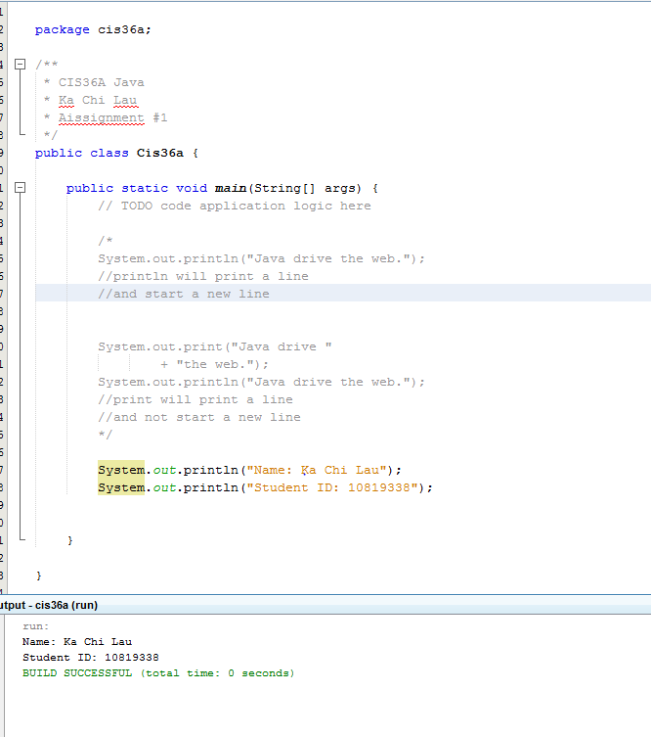

Once you have completed your Program attach a picture of your program to this assignment and submit using your flash drive during lab-time on Tuesday 1/27/15